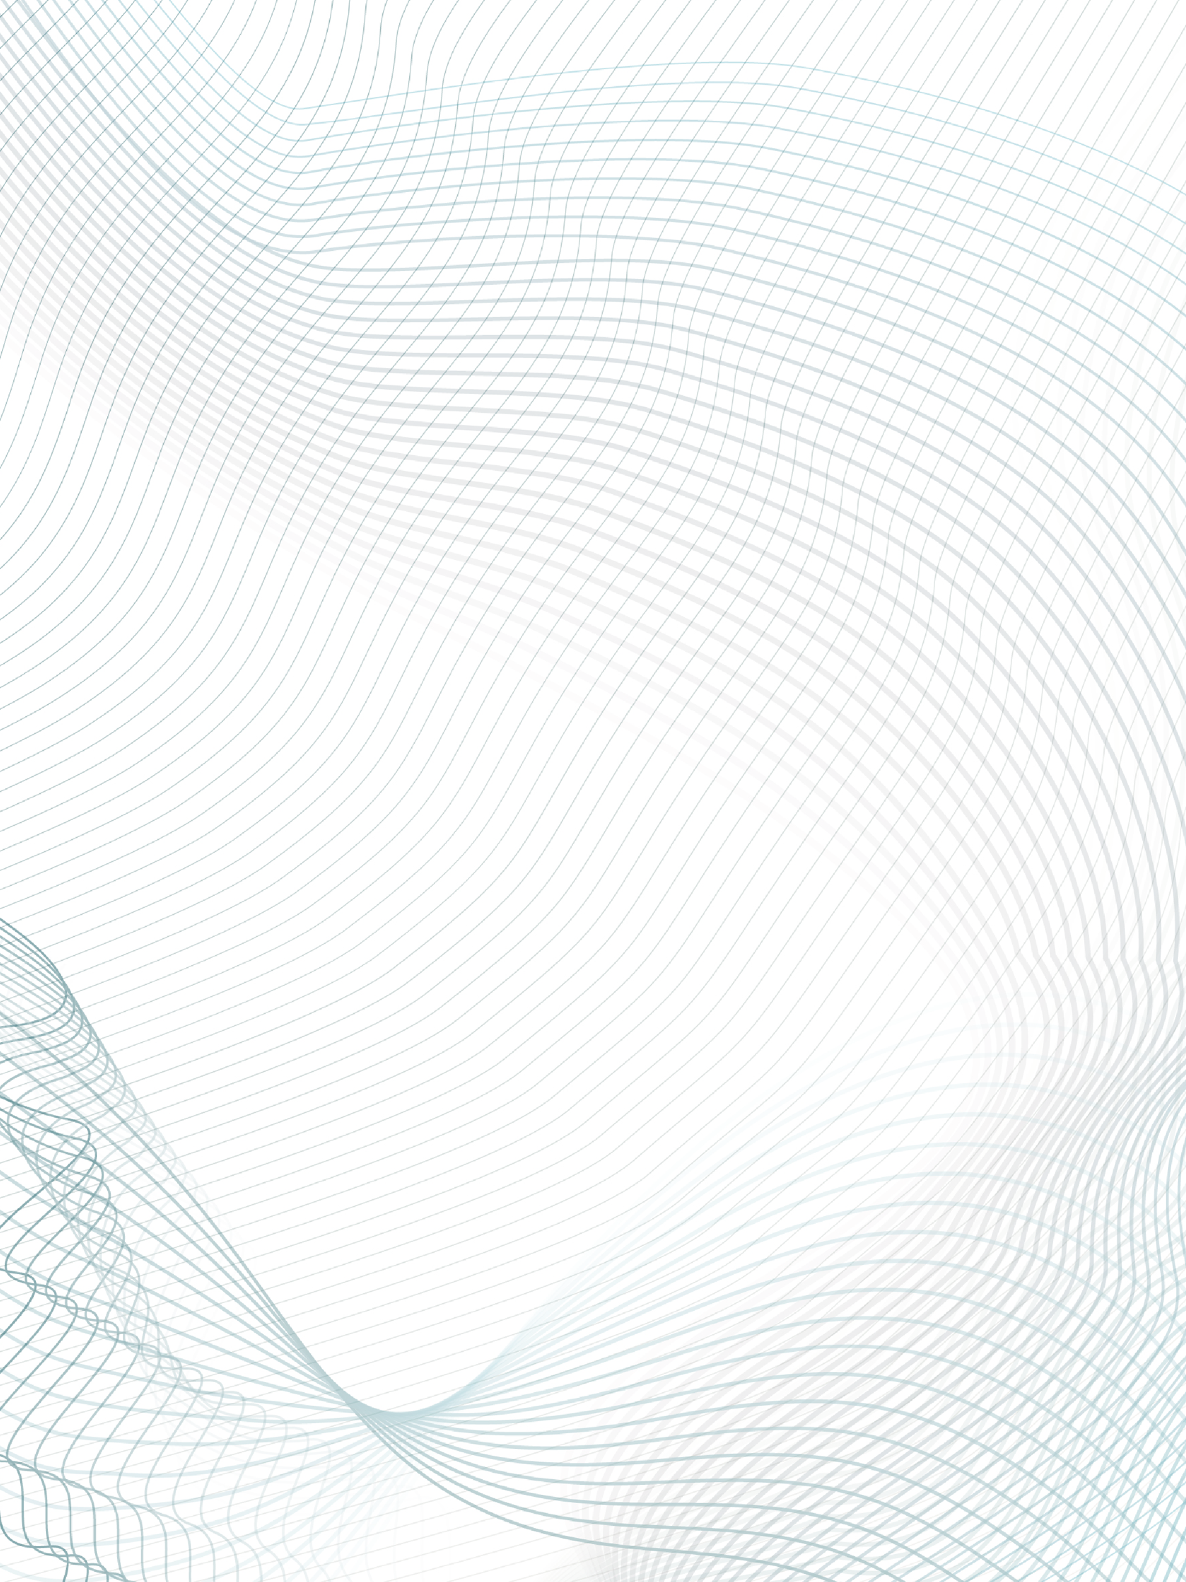

Specification Document

Lab 1

COMP8117-1-R-2021S

SUBMITTED TO:

Dr. Aznam Yacoub

LAB PARTNER

ARSHDEEP KAUR

110030302

SUBMITTED BY:

ANUBHA SHARMA

110037181

CHAMBER

Version 1

25-05-2021



Contents

1. INTRODUCTION 3

2. BUSINESS REQUIREMENTS 3

3. CONstraints 4

4. Functional requirements 4

5. NON-FUNCTIONAL REQUIREMENTS 11

6. System Features 11

7. High level use case diagram 12

References 13

# INTRODUCTION

#### Purpose of the document [1]

The purpose of this document is to analyze the business requirement as specified by the customer and propose a solution. The purpose is to gain agreement between business clients and technical team and to provide direction to technical team in designing, developing and testing the end product. The intended audience of this document is the technical team and project business client.

1. **Project Summary** [2]

|  |  |
| --- | --- |
| **Project Name:** | Chamber |
| **Domain:** | Household automation |
| **Customer:** | Toto Inc. |
| **Software Engineer:** | Anubha Sharma |
| **End Users:** | Anyone using smart devices in their homes and people living in basements |

1. **Problem Statement and Business opportunity**

Toto Inc. will like to develop a new kind of automated bedroom. This bedroom will address the problem of the unavailability of the sun in the basement apartments. The bedroom will also recommend clothing according to the weather and planned events, play music to improve the mood, suggest a fitness program and rest program.

# BUSINESS REQUIREMENTS

In the table below, just the high-level requirements are provided. Each requirement is described in greater detail later in the document and can be recognized using the requirement identifier.

|  |  |  |
| --- | --- | --- |
| **Requirement Identifier** | **Description** | **Comments** |
| BR-1.1 | Create an account for the user on the application. |  |
| BR-1.2 | Develop an interface to add smart lights to the system. |  |
| BR-1.3 | Develop a system to get real-time information on temperature, humidity, wind speed (to measure real-time sunlight). |  |
| BR-1.4 | Depending on the time, the intensity of the lights grouped into the “good morning lights” category will be changed. |  |
| BR-1.5 | Depending on the time change the settings of smart blinds or curtains |  |
| BR-1.6 | Create a music recommendation system for end-user |  |
| BR-1.7 | design an interface to track a user's physical health |  |
| BR-1.8 | Based on 1.7, create a personalized fitness and sleep program |  |
| BR-1.9 | Create a personalized clothing program for the user, depends on BR-1.3 |  |
| BR-1.10 | Develop an interface to control smart lights from the application |  |
| BR-1.11 | Settings Tab and options under it. |  |
| BR- 1.12 | Home Page and options under it. |  |

# CONstraints

|  |  |
| --- | --- |
| 1. | WIFI connectivity is required in the home. |
| 2. | For now, we will only support smart lights and plugs with built in wireless remote controller. |
| 3. | For real-time information on the weather, we will depend on 3rd part services. |
| 4. | User should be able to use a mobile device |
| 5. | User should have either a mobile device or tablet to operate the system |

# Functional requirements

Below we will analyze the functional requirements corresponding to each business requirement

1. **BR-1.1: Create an account for the user on the application.**

The first step for the user will be to create an account in the application by linking it with a phone number or email ID and password. The user can also sign up for an account using Facebook. OTP verification will be performed when creating an account using a mobile number and Gmail.

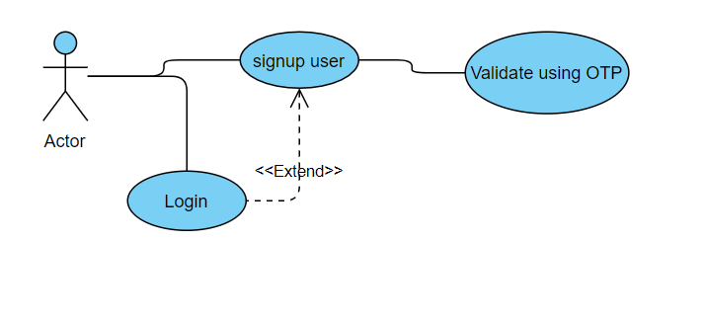

1. **BR-1.2: Develop an interface to add smart lights to the application.**

Our app allows users to add their smart appliances. The option to add smart lights will be on home page. The user will add the appliances one at a time and can rename them. They can also group them into categories for ease of usability. For example, this will allow the user to issue a single command for the category. The user can rename the category as well. A category should only have the same kind of appliances. For example, lights should group with lights, plugs should group with plugs, etc.

* ADDING SMART APPLIANCE TO APPLICATION.

(FOR EASE OF WRITING, I HAVE USED BULB AS THE APPLIANCE. BUT THE UNDERLYING PROCESS WILL BE SAME FOR ALL THE APPLIANCES)

WIFI technology will be used to detect the smart bulbs. The device that runs the application will serve as a hotspot for the smart bulbs. When the bulb is turned on and off four times, it sends a signal to the micro-controlled in smart bulb to search for a WLAN to pair with. While searching for a signal, the bulb will continue to blink to alert the user that the pairing process is in progress. The blub will stop blinking once the pairing process is complete.

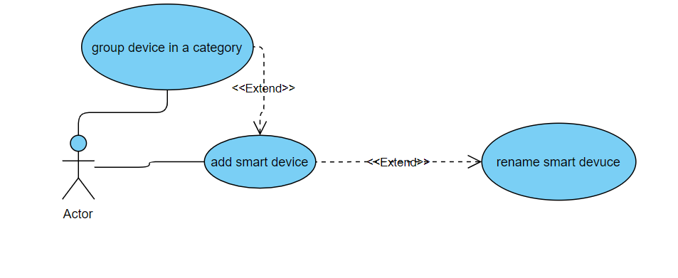

1. **BR-1.3:** **Develop a system to get real-time information on temperature, humidity, wind speed (to measure real-time sunlight)**

Use an existing API to collect temperature, humidity, sunshine, rain, snow and wind speed data for that day in the city selected by the user in their account, and save it to the database. The utility will run once at 4:00 a.m. and retrieve data for the entire day, from 4:00 a.m. to 10:00 p.m.

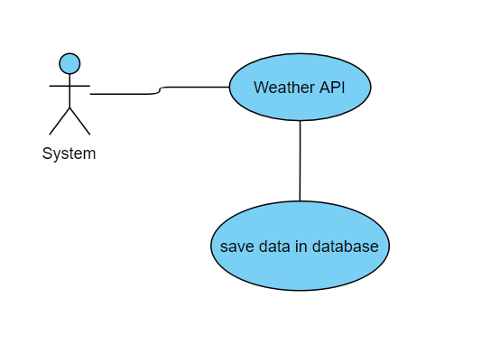

1. **BR-1.4: Depending on the time, the intensity of the lights, grouped into the “good morning lights” category, will be changed**

Using the current time, change the intensity of the smart bulbs in the room. The minimum and maximum intensity of the “good morning lights” can be set by the user using the settings. Also, the start time i.e., when this process should begin, can be set in the settings. Our default time would start at 6:00 a.m., but as discussed it is configurable by the user. The default color of lights is set to yellow but that is too configurable by the user. The process will last for half hour from starting time i.e., after half hour the intensity of lights will be maximum.

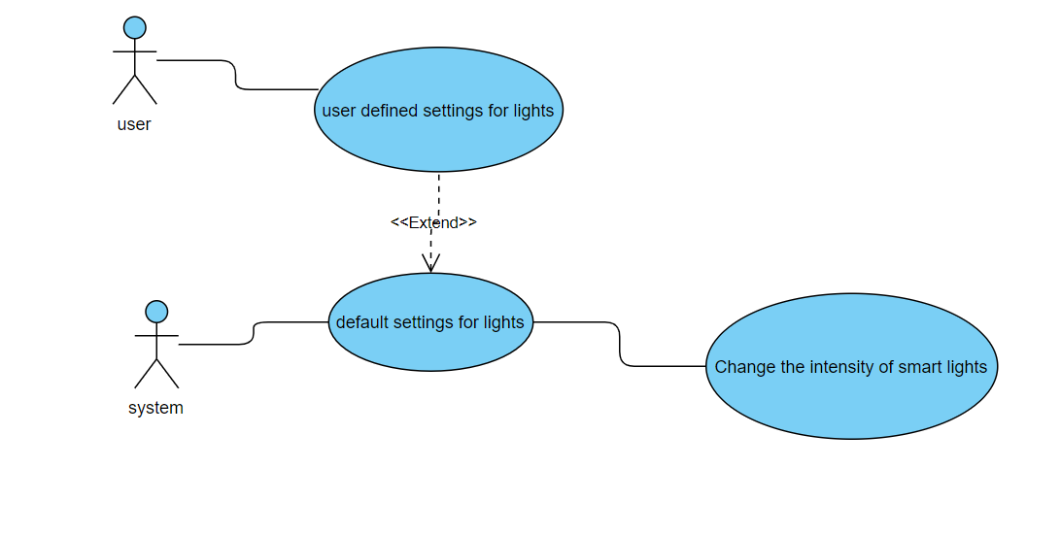

1. **BR-1.5: Depending on the time change the settings of smart blinds or curtains**

If the user has added smart curtains as the appliance, depending on the time we will change the settings. The blinds will be opened at 6:00 a.m. in the morning to let the sunlight enter the room. These settings are customizable. The settings for good mornings lights will be used for smart blinds

As well. In addition to these, we will build a separate interface which will control the smart blinds

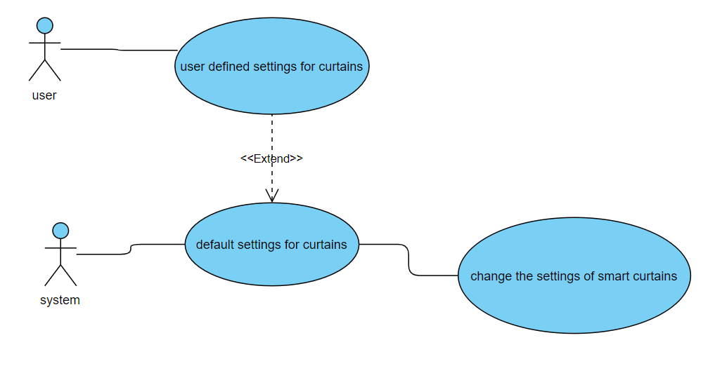

1. **BR-1.6: Create a music recommendation system for end-user**

In the settings tab, under good morning tones, we will give a list of various moods. The list of moods will also be listed on the homepage under the moods section. The list will include calm mood, happy mood, active mood, cheerful mood, romantic mood, lighthearted mood. The user will select the mood which they would prefer in morning. These instructions will be transferred to the smart speaker, which will play these tunes in the morning at a preset time.

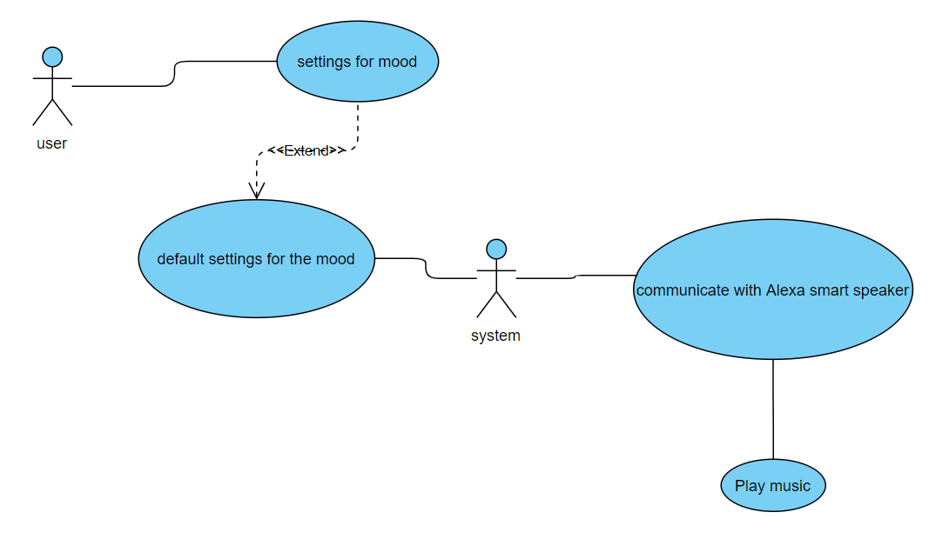

1. **BR-1.7: Design an interface to track a user's physical health**

The user will enter their health information in the personal details section on Home Page. The user's current medication, any health issues, weight, height, the user's end goal (weight loss, muscle gain, overall health improvement), how many times and when they would like to work out, and so on. All of this information must be stored in the database. After analyzing the user's health parameters, we will assign a category to them. For the time being, there are five categories: the diabetic profile, blood pressure profile, joint pain profile, heart patient, weight loss profile, and muscle gain profile.

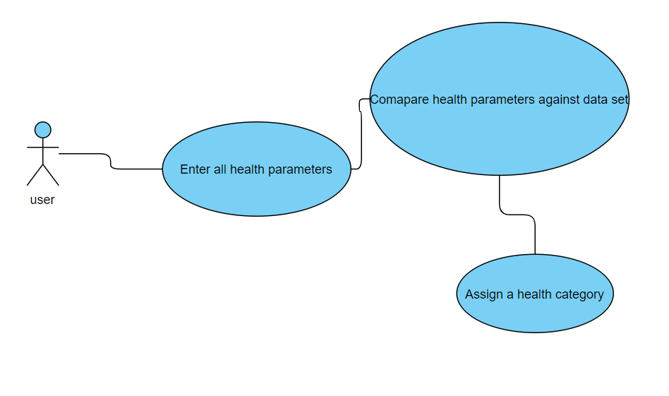

1. **BR-1.8: Based on 1.7, create a personalized fitness and sleep program**

* FITNESS PROGRAM

We will have some preset routines in our application that will be developed by hiring a dietician to recommend a personalized training format to the user for a particular category. The application will provide links to YouTube videos, created by our instructors, with instructions on how to complete the exercise. The number of times the exercise should be repeated will also be provided. These routines will be updated regularly.

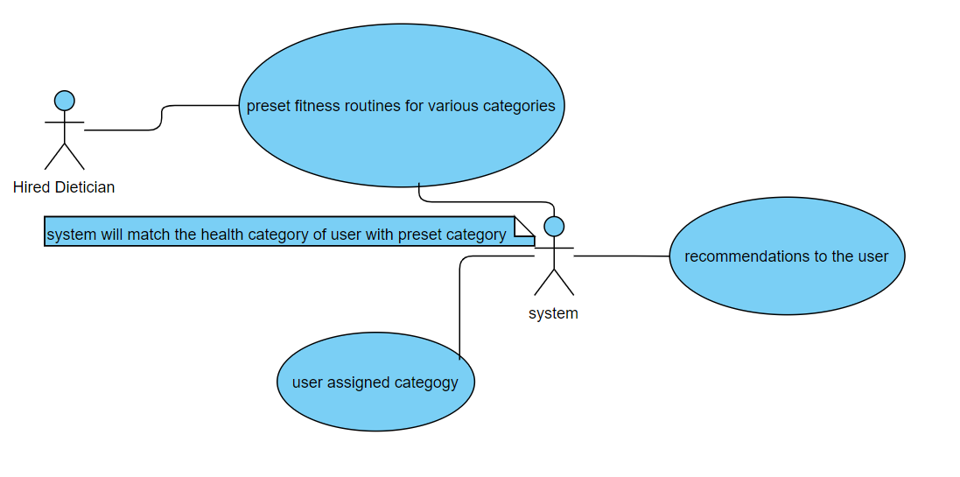

* REST PROGRAM

Similarly, for the sleep program, the hired doctor will develop pre-programmed instructions for various categories. These will be matched to the user’s category and offered as a suggestion. We will also provide the user with the recommended for pre-bedtime ritual. Pre bed time rituals will have recommendations for which personal products to use, what to eat, what to drink, reminding if there are any medications that user needs to take before going to sleep. All these recommendations will be based on the heath parameters provided by the user in the health section and category assigned to the user.

We will also make suggestions for the type of mattress the user should use. If the user has a smart mattress that has been added as an appliance to the application, the settings for the mattress will be done automatically after the user has approved it. The health parameters like body temperature, heart rate, breathing will be gathered from the smart mattress and recorded in the database to analyze the sleep patterns and improve the recommendations.

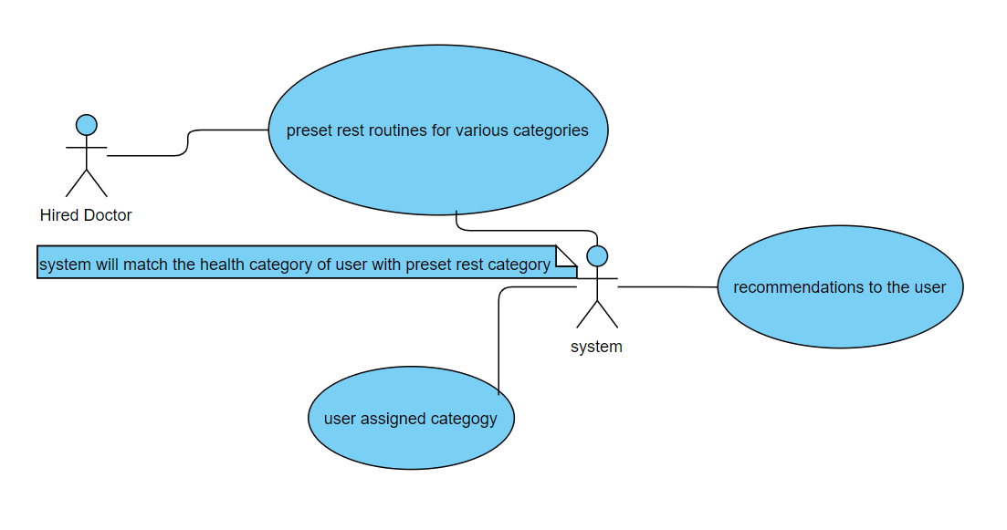

1. **BR-1.9: Create a personalized clothing program for the user, depends on BR-1.3**

The following will be done to solve the problem of recommending personalized clothing to the user.

* INTEGRATING CALENDAR TO GET USERS PLANNED EVENTS

We will integrate google calendar in our application. In the settings tab the user will choose the calendar option and input the account information for the google calendar. We will use google calendar API to achieve this task and get the planned events from the calendar.

* MAKE A DATASET TO MAP WEATHER CONDITIONS AND TYPE OF EVENTS TO THE TYPE OF CLOTHING [3]

We will make a large dataset which will map various weather conditions like rain, sunshine, windy, etc. and type of events like office, cocktail, party, shopping, etc. to the type of clothing. The type of clothing being colors, patterns, clothing category (summer, winter), etc. we will rigorously test this model and make what-to-wear dataset.

* MAKE A RECORD OF USER’S PERSONAL CLOSET.

User will click pictures of what they already have. From the image we will deduce whether the picture is jacket, T-shirt, jeans, skirt etc., the colors and patterns and make of list of things in user’s closet

WORKING

On the home screen, the user will select “what to wear". The application will show the events scheduled for the day. If the user did not store the planned event in a calendar or made an on-the-spot plan, the user will be given the option to change the type of event. The application will then analyze the event, taking weather factors into account, and make an intelligent match with user’s personal closet list.

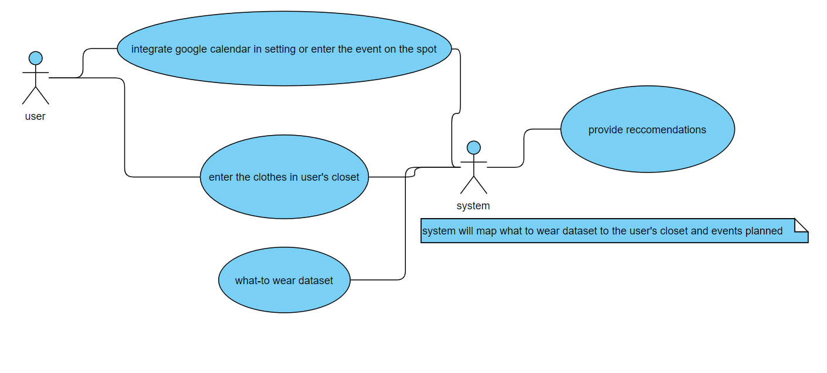

1. **BR-1.10: Develop an interface to control smart lights from the application**

We will develop an interface to change the settings for the smart lights. Depending on the settings of the user, the interface with send signals to the smart lights. We will push the commands, i.e., the intensity, colors, etc. on the IoT hub. From there the micro-controller will pick up the settings and change settings of the appliance accordingly.

1. **BR-1.11: Settings Tab and options under it.**

The settings tab in the application will have below option.

* Heath tracker:

to input health parameters

* Good morning lights:

to set the settings for morning lights

* Calendar:

integrate google calendar

* Good Morning Tones:

To set the settings for the mood and tunes user will prefer in morning

* Account information

Display the account information, email or phone number used to signup, WIFI connection information and profile picture

1. **BR-1.12: Home Page and options under it.**

The home page will have below options

* Fitness:

To provide fitness routine for that day

* What-To-Wear:

Provide recommendations for clothing

* Sleep Well

Provide recommendations for resting well at night.

# NON-FUNCTIONAL REQUIREMENTS

1. Responsiveness:

The site should move from one page to another with 10-20 ns.

1. PRIVACY

The user’s account information should be private and should be stored in database in an encrypted format.

1. PERMISSIONS:

The applications will take permission for the usage of the resources of the device, like GPS, notification, camera, files and media, etc.

# System Features

1. SMART BULBS:

We will need to use smart blubs that can be controlled wirelessly, and are dimmable. We will use bulbs from Wipro. The interface to others will be added later on.

1. Operating System:

The application will be supported for IOS, Android and Windows smart phones.

1. POWER REQUIREMENT:

220-240 v,

50-60 Hz

1. HARDWARE:

The application will be tested on mobile devices of screen size 4.5 inches to 7.5 inches and tablets (Apple).

1. WIFI Connection:

Minimum of 2.4 Ghz band is required for the setup.

1. SMART SPEAKERS

Smart speakers will be integrated in the application to play customized music at preset times. We will use Alexa as the smart speakers, and will develop an interface with Alexa application.

1. SMART BLINDS

Smart blinds will be added to the application to play music in the morning. The smart blinds that we will be using are also from Wipro. The interface to others will be added later on.

# High level use case diagram

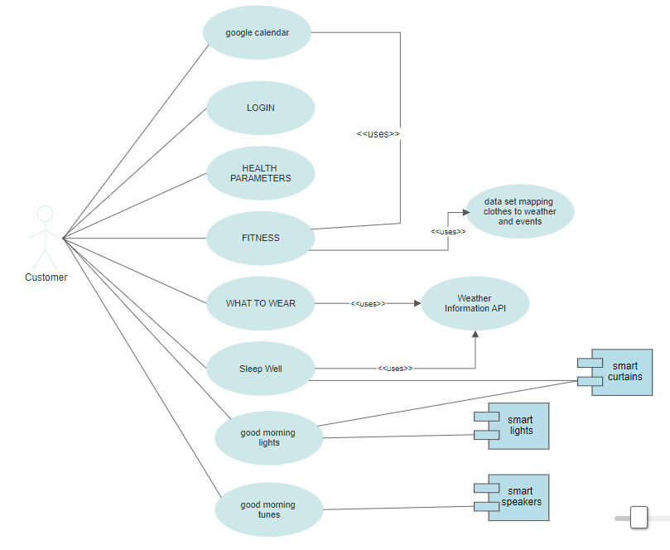

# References

|  |  |
| --- | --- |
| [1] | "https://www.lucidchart.com," [Online]. Available: https://www.lucidchart.com/blog/tips-for-a-perfect-business-requirements-document. |
| [2] | "http://web.cse.ohio-state.edu/," [Online]. Available: http://web.cse.ohio-state.edu/~bair.41/616/Project/Example_Document/Req_Doc_Example.html. [Accessed 26 05 2021]. |
| [3] | "https://dl.acm.org/," [Online]. Available: https://dl.acm.org/doi/10.1145/2393347.2393433. [Accessed 28 05 2021]. |